# DMC Exercise 9.8(c)

**Use the integration method to get upper and lower bounds for these sums. Then determine the “simplest” function f(n) for which the sum is in** **ϴ(f(n)).**

**(c) $\sum_{i=1}^{n}{i*2^{i}}$**

We can write i*2i as f(x) = x*2x. f(x) is the product of two increasing functions (x, a polynomial and 2x, a exponential function) so it, too, is an increasing function. That means we can write the sum like so:

$$\int_{0}^{n}{x*2^{x} dx} ≤ \sum_{i=1}^{n}{i*2^{i}} ≤ \int_{1}^{n+1}{x*2^{x} dx}$$

We can then integrate the left side like so:

$$\int_{0}^{n}{x*2^{x} dx }\left|\begin{matrix}u=x & v=\frac{2^{x}}{ln⁡(2)} \\ du=dx & dv=2^{x}dx\end{matrix}\right.\left|=\frac{\left(x*2^{x}\right)}{\ln\left(2\right)}- \int{\frac{2^{x}}{\ln\left(2\right)}}=\frac{x*2^{x}}{\ln\left(2\right)}-\frac{2^{x}}{\ln\left(2\right)} \right| {n \atop 0}=\frac{\left(n*2^{n}\right)}{\ln\left(2\right)}-\frac{\left(2^{n}+1\right)}{\ln^{2}{2}}$$

Thus

$$\sum_{i=1}^{n}{i*2^{i}} ∈ ϴ\left(\frac{\left(n*2^{n}\right)}{\ln\left(2\right)}-\frac{\left(2^{n}+1\right)}{\ln^{2}{2}}\right)$$

# DMC Exercise 11.9

**The graph is an ISP (internet service provider) network where the vertices are the ISPs. Links are connections between ISPs and edge weights are packet travel times in milliseconds (e.g. the direct link between the two red ISPs takes 20 ms to traverse). How quickly can one route a packet between the red vertices?**

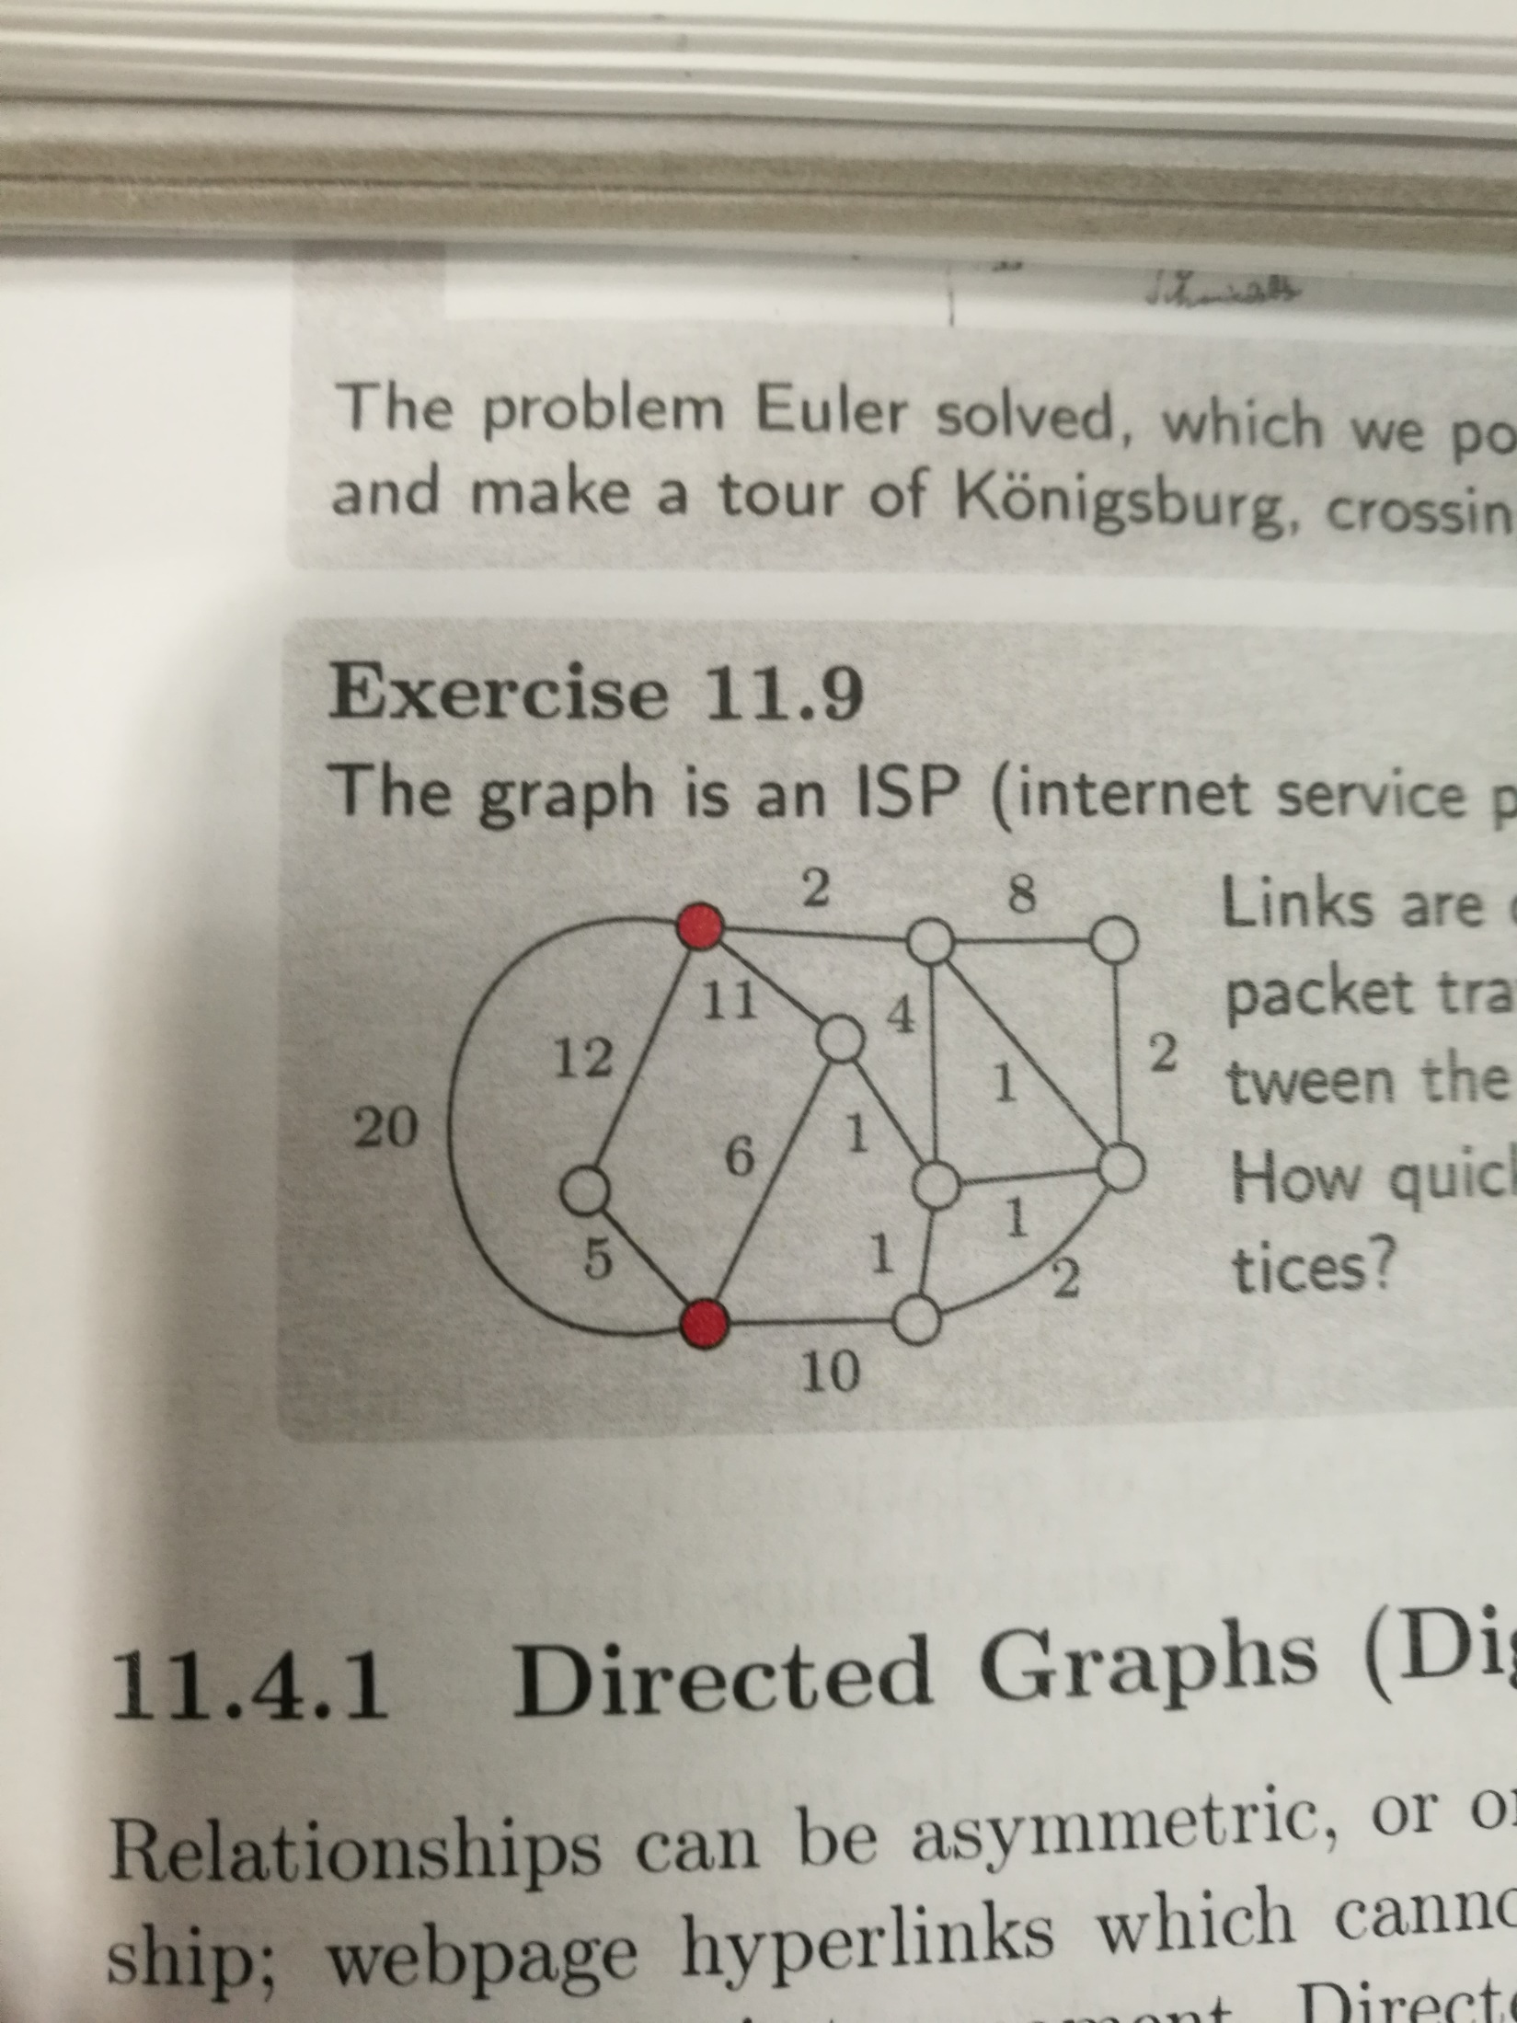

I approached this problem by starting at the lowermost red dot and drawing paths to the other red dot, starting with the leftmost possible path then working my way right.

I found that the shortest path involves traveling along the path of weight 6, then the path of weight 1, then the path of weight 1 that goes due east, then the northwest path of weight 1, the finally the path of weight 2 (A diagram is below).

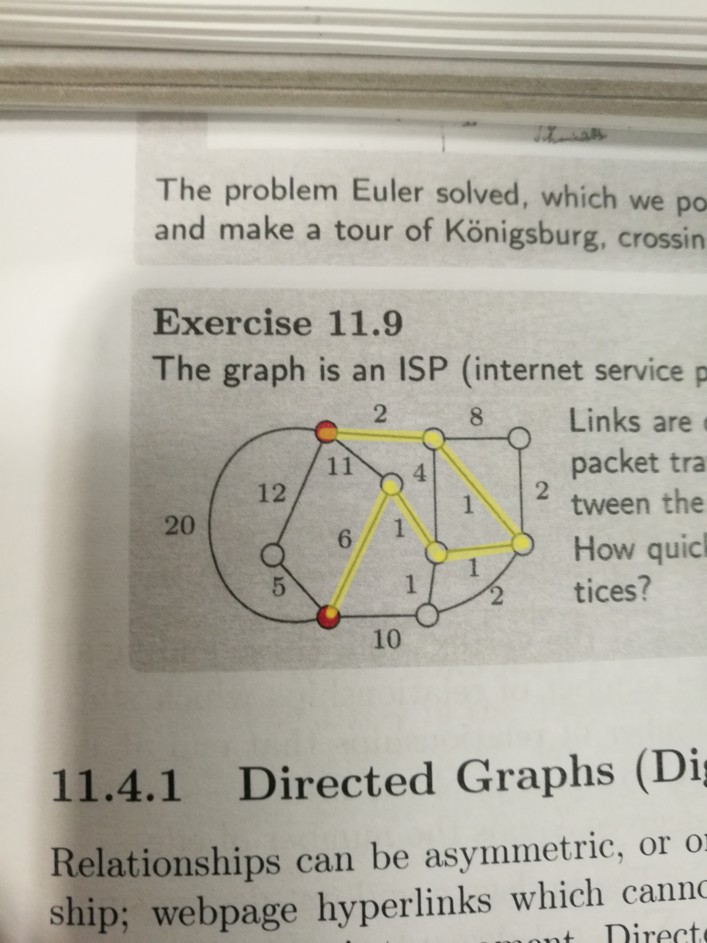

This path has a total time of 6+1+1+1+2 = 11 which is the smallest possible travel time.

# DMC Problem 10.2(a)

**Use Euclid’s algorithm and the remainders generated to solve these problems.**

**(a) Compute gcd(2250, 1200) and find x,y $∈$ Z for which gcd(2250, 1200) = 2250*x + 1200*y.**

Gcd(2250, 1200)

= gcd(1200, 2250) (obvious theorem mentioned in the book)

= gcd(1050, 1200) (2250 % 1200 = 1050)

= gcd(150, 1050) (1200 % 1050 = 150)

= gcd(0, 150) (1050 % 150 = 0)

= 150 (because gcd(0, n) = n)

To find x and y

gcd(1200, 2250)

= gcd(1050, 1200) (1050 = 2250 – 1200)

= gcd(150, 1050) (150 = 1200 – 1050 = 1200 – (2250 – 1200) = 1200*2 -2250*1)

= gcd(0, 150)

= 150

It’s easy to see from the work above that (1200*2)-2250 = 150. Thus if x = -1 and y = 2, we have:

-2250 + (1200*2) = 150.

# DMC Problem 10.2(b)

**Find x and y as in (a), but with the additional requirement that x ≥ 0 and y ≤ 0.**

I tinkered with values until I got a correct answer.

|  |  |  |
| --- | --- | --- |
| **X** | **Y** | **2250x + 1200y = Result** |
| 1 | -1 | 1050 |
| 1 | -2 | -150 |
| 2 | -1 | 3300 |
| 2 | -2 | 2100 |
| 2 | -3 | 900 |
| 2 | -4 | -300 |
| 3 | -1 | 5550 |
| 3 | -2 | 4350 |
| 3 | -3 | 3150 |
| 3 | -4 | 1950 |
| 3 | -5 | 750 |
| 3 | -6 | -450 |
| 4 | -1 | 7800 |
| 4 | -2 | 6600 |
| 4 | -3 | 5400 |
| 4 | -4 | 4200 |
| 4 | -5 | 3000 |
| 4 | -6 | 1800 |
| 4 | -7 | 600 |
| 4 | -8 | -600 |
| 5 | -1 | 10050 |
| 5 | -2 | 8850 |
| 5 | -3 | 7650 |
| 5 | -4 | 6450 |
| 5 | -6 | 4050 |
| 5 | -7 | 2850 |
| 5 | -8 | 1650 |
| 5 | -9 | 450 |
| 6 | -1 | 12300 |
| 6 | -5 | 7500 |
| 6 | -7 | 5100 |
| 6 | -9 | 2700 |
| 6 | -10 | 1500 |
| 6 | -11 | 300 |
| 7 | -1 | 14550 |
| 7 | -10 | 3750 |
| 7 | -13 | 150 |

If x = 7 and if y = -13, then we have 2250(7) + (1200)(-12) = 150.

# DMC Problem 10.9(a)

**Solve the problem using the jugs provided, or explain why it can’t be done.**

**(a) Using 6 and 15 gallon jugs, measure 3 gallons, 4 gallons, and 5 gallons.**

We know from Bezout’s identity that gcd(m, n) = mx + ny when x and y are integers. We can combine this idea with an equation to model the jug situation to come up with a general solution to this problem.

First, if we let m and n equal the jug sizes, then x and y can equal the number of times a jug is filled (when x or y are positive) and the number of times a jug is emptied (when x or y are negative).

Thus we have: K = 6x + 15y where K is the amount of water left in a jug. We can sub in gcd(6,15) = 3 in for K to get:

3 = 6x + 15y.

This proves that measuring 3 gallons is possible. 6*-2 + 15*1 = 3. One would have to empty the 6 gallon jug twice and fill the 15 gallon jug once. Here’s an example of the process (Let (a,b) represent the amount of water in the 6 and 15 gallon jugs, respectively):

(0,0) 🡪 (0,15) 🡪 (6,9) 🡪 (0,9) 🡪 (6,3).

This same formula proves that it is impossible to produce measurements of 4 and 5 gallons with 6 and 15 gallon jugs. Since 4 and 5 are not divisible by 3, there is no way to manipulate the formula such that the left hand side equals 4 or 5 and that the right hand side numbers stay integers (a condition of Bezout’s identity).

# DMC Problem 10.9(b)

**(b) Using 5 and 11 gallon jugs, measure 6 gallons and 7 gallons.**

Using the same process from the previous question, we can write out a formula like so:

Gcd(5, 11) = 1, so: 1 = 5x + 11y

Multiply both sides by 6 and we have: 6 = 30x + 66y. This is solved when x = -2 and y = 1.

Thus, 6 Gallons can be measured like so:

(0,0) 🡪 (0,11) 🡪 (5,6) 🡪 (0,6)

(As pointed out in the book, sometimes you can arrive at your solution a bit earlier. The formula is simply a handy way for proving that a measurement is possible).

For measuring 7 gallons we multiply both sides of the formula by 7.

7 = 35x + 77y. This is solved when x = -2 and y = 1.

7 Gallons can be measured like so:

(0,0) 🡪 (0,11) 🡪 (5,6) 🡪 (0,6) 🡪 (5,1) 🡪 (0,1) 🡪 (1,0) 🡪 (1,11) 🡪 (5,7)

# DMC Problem 10.24(a)

**The hour hand is currently at 3. Where will the hour hand be after:**

**(a) 233 hours.**

Let the first row be the number of hours past and the second row the current hand position.

|  |  |  |  |  |  |  |  |  |  |  |  |  |  |  |  |  |  |  |  |  |  |  |
| --- | --- | --- | --- | --- | --- | --- | --- | --- | --- | --- | --- | --- | --- | --- | --- | --- | --- | --- | --- | --- | --- | --- |
| 0 | 1 | 2 | 3 | 4 | 5 | 6 | 7 | 8 | 9 | 10 | 11 | 12 | 13 | 14 | 15 | 16 | 17 | 18 | 19 | 20 | 21 | 22 |
| 3 | 4 | 5 | 6 | 7 | 8 | 9 | 10 | 11 | 12 | 1 | 2 | 3 | 4 | 5 | 6 | 7 | 8 | 9 | 10 | 11 | 12 | 1 |

The hand position cycles from 3, 4, 5, 6, 7, 8, 9, 10, 11, 12, 1, 2 and then repeats.

I knew, since the sequence repeats every 12 steps, I’d have to use the N % 12 operation somewhere in a potential function.

I knew that the minimum value in the sequence had to be 1, so I added a +1 as a constant.

Combining these facts, I wrote a function f(x) = 1+[(x+2) % 12] that correctly models this sequence.

With this, I can just plug in the number 233 to solve for the correct number.

To calculate 235 % 12, I know that 12*20 = 240, so I can figure that 12 goes into 235 19 times. 12*19 = 228 and 235 – 228 = 7. Adding 1 to the remainder gives us a final result of 8.

# DMC Problem 10.24(b)

**The hour hand is currently at 3. Where will the hour hand be after:**

**(b) 14 * 233 hours**

Plugging 14*233 into the formula yields the result 1.

# DMC Problem 10.24(c)

**The hour hand is currently at 3. Where will the hour hand be after:**

**(c) 233233 hours.**

# DMC Problem 11.24(a)

**Recall that any social network with 6 people has a 3-person friend clique or a 3-person war. This is remarkable. No matter how random the network is, there is always some structure. Can we insist on more structure? Yes, by increasing the size.**

**(a) Show that any social network with 10 people has a 4-person friend clique or a 3 person war.**

# DMC Problem 11.24 (b)

**(b) Show that any social network with 9 people has a 4 person friend clique or a 3 person war. [Hints: Assume no 3-person war and use contradiction to show that there is a 4-person friend clique. To get a contradiction, show that every vertex has 3 enemies and 5 friends.]**